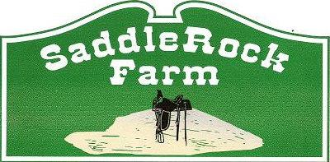

**HORSE CAMP REGISTRATION**

SaddleRock Farm’s Horse Camp is the highlight of summer, offering an unforgettable experience for kids aged 6 and up. Campers will ride and care for five different horses while rotating through interactive stations to develop new skills. Our week-long camps run Monday through Friday, 9:30 AM to 4:00 PM, for just $300 per week. A $60 nonrefundable deposit is required to secure your spot, with the remaining $240 due one month before camp begins. Space is limited to 20 campers per session, so submit your registration form and deposit soon to guarantee your place!

**2025 Horse Camp Dates:**

* May 26-30th
* June 16-20th
* July 7-11th
* August 4-8th

Child’s name: ______________________

Child’s age: ____

Parents name: ______________________

Parents cell number: __________________

Child’s t-shirt size: (please state adult or youth) ________

Camp you’re interested in: ______________

Parent signature:___________________

DEPOSIT IS DUE WHEN SUBMITTING THIS FORM!

For more information contact Emily Parker at 919-690-5610